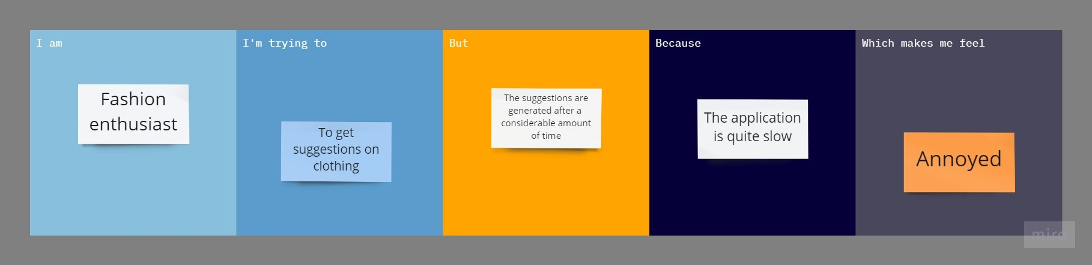

**SOLUTION FIT**

|  |  |  |
| --- | --- | --- |
| **1.CUSTOMER SEGMENT:**  The customer has a keen interest on fashion and is aware of the latest trends. | **2.JOBS-TO-BE-DONE/PROBLEMS**:  The suggestions are generated after a considerable amount of time**.** | **3.TRIGGERS:**  The application is quite slow when compared to other applications. |
| **4.EMOTION:BEFORE/AFTER:**  **BEFORE**: Annoyed and frustrated.  **AFTER**: Content, gratified and satisfied. | **5.AVAILABLE SOLUTIONS:**  Using the application on a different OS or using different application altogether. | **6.CUSTOMER CONSTRAINTS**:  Spending power, network issues and limitation in available devices. |
| **7.BEHAVIOUR:**  **DIRECTLY RELATED**: Install the latest OS version or install a better application.  **INDIRECTLY ASSOCIATED**: Read fashion magazines in free time. | **8.CHANNELS OF BEHAVIOUR:**  **ONLINE:** Keep updating new versions of OS or the application itself frequently.  **OFFLINE:** Read magazines to gain more knowledge on fashion so that dependence on an application reduces. | **9.PROBLEM ROOT CAUSE:**  Customers need to keep updating the newer versions of OS as the older versions stop supporting an application after a point of time. |
| **10. YOUR SOLUTION:**  Develop an application which runs on a wide range of operating systems and gives a faster and more accurate suggestion. |